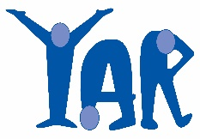
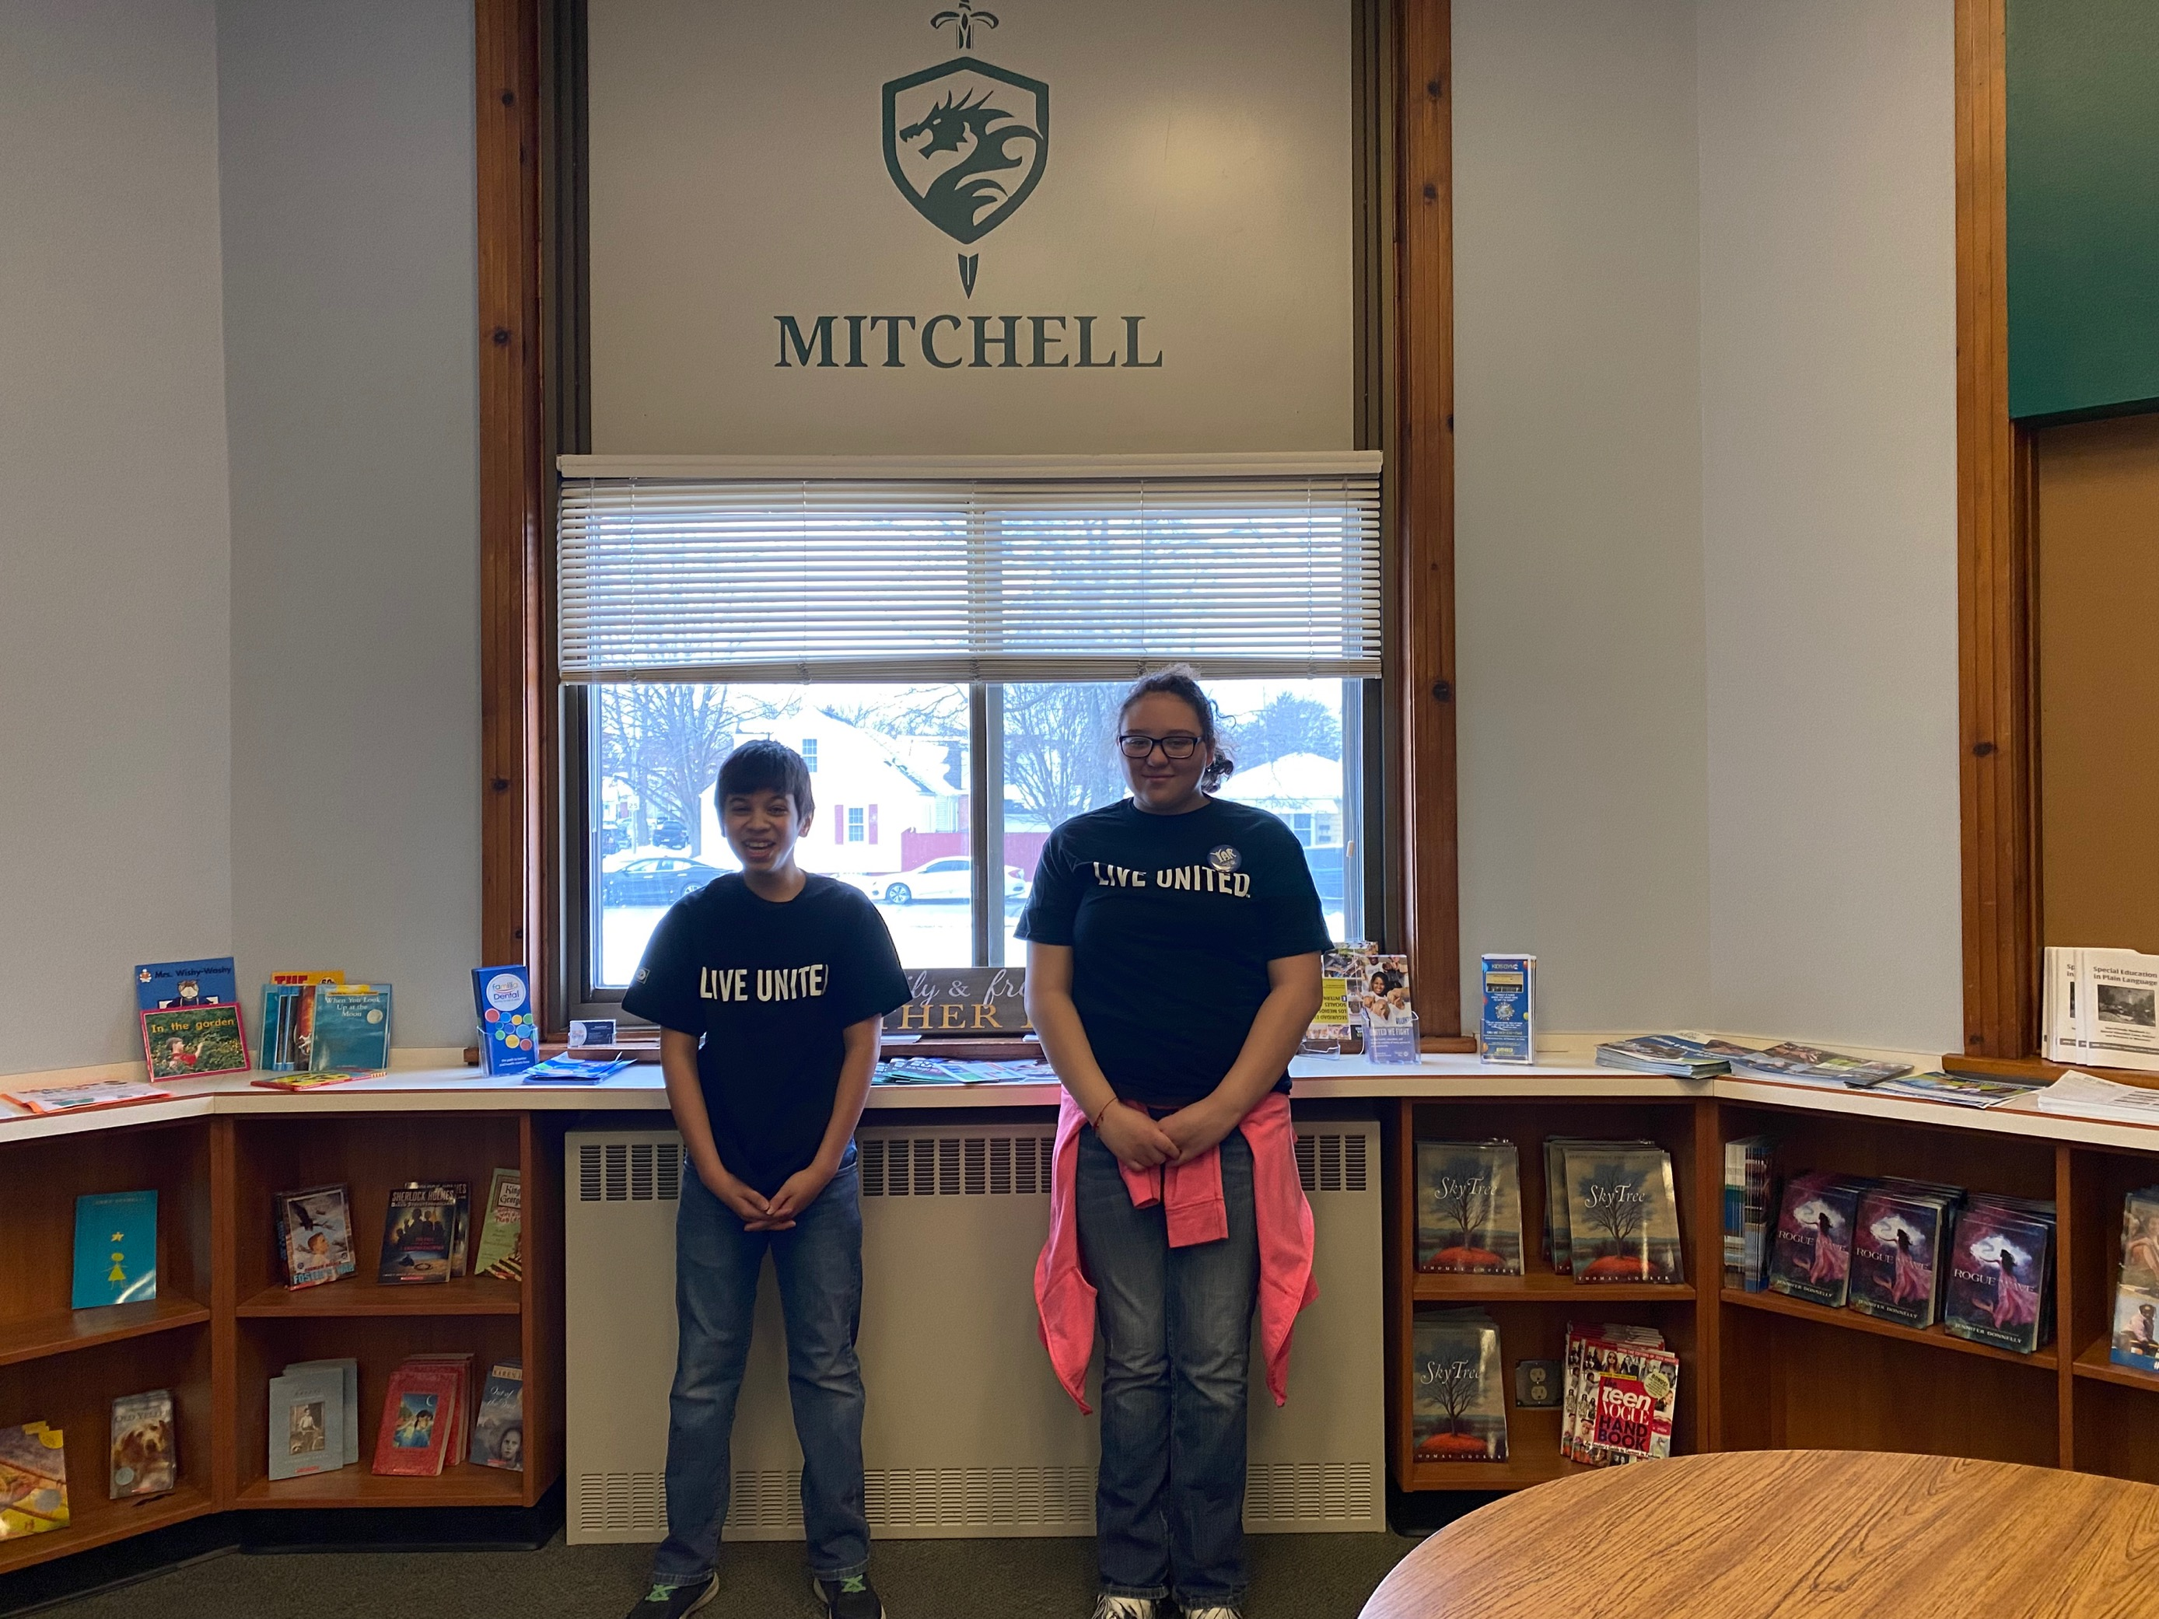  Youth As Resources (YAR)  Fund Description, Application and Reporting Requirements | Table of Contents  1 Fund Description  1 Youth as Resources Board Responsibilities  1-2 YAR Fund Eligibility & Requirements  2-4 Application Timeline and Process  4 Reporting Requirements  5-7 Application Questions  8-10 Reporting Requirements (Application Version)  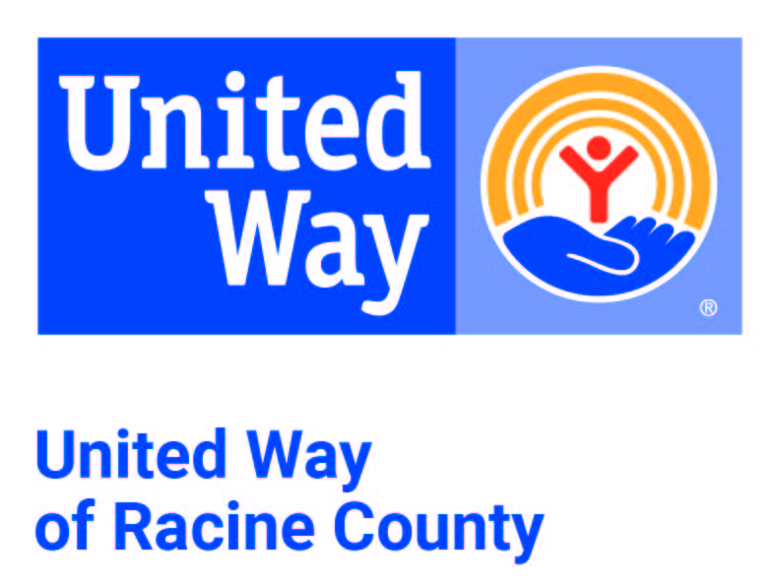

Fund Description
United Way of Racine County’s Youth As Resources (YAR) empowers young people to make a positive difference in Racine County through grant making and community service. YAR provides grants to fund youth-designed, youth-led community service and service learning projects. YAR projects feature youth as planners and volunteers while creatively address specific community needs or problems, such as environmental, social and cultural awareness issues. Since 1996, YAR has funded 405 community service projects totaling over $273,995. More than 32,000 youth and adults in Racine County have been involved in YAR-funded projects. The Youth As Resources pool of funds is a subset of the community investment pool.

- The purpose and function of YAR is to support United Way’s community impact strategies as follows: Provide funding for supplies needed to complete youth-designed, youth-led community service and service learning projects.
- Promote youth as valuable community members who have ideas and are able to take on responsibilities with energy and skill.
- Empower youth to develop and apply their ability to change themselves and the world in which they live through active participation in the relationships, events and organizations that impact their lives.
- Foster youth/adult partnerships where adults play a significant role as respectful partners, where both youth and adults share power and decision making.
- Promote the direct involvement of youth in their communities as productive workers, as change agents, and as advocates for themselves and others in organizations throughout the community.
- Promote youth gaining knowledge and new skills while providing support and challenging opportunities.

Youth As Resources Board and Board Responsibilities
The YAR board is a model of youth-adult partnership at the Academies of Racine at Mitchell Community School.
- Attend and actively participate in regularly scheduled YAR meetings and board service projects.
- Review grant applications and submit questions, attend project presentations and make funding recommendations.
- Oversee and monitor funded projects through site visits and written reports.

YAR Fund Eligibility
Any group of youth (up to age 24) from community organizations, religious communities, schools, classrooms, clubs, service groups and other nonprofit organizations may apply for a YAR grant up to and including $1,000.

YAR grants are awarded to projects that:
- Are planned, led and implemented by youth with adult advisors.
- Address a community need or problem clearly and creatively.
- Can be started and finished by the same group of youth in a reasonable amount of time.
- Have solid, well-organized plans and a realistic, cost-effective budget.
- Create and work within the community through the donation of services, talents and materials.
- Publicize the positive work being done by youth to improve Racine County.
- Include reflection activities that help youth gain insight into how they can make the world a better place.

Each YAR project must have a nonprofit sponsoring organization. The sponsoring organization is required to:
- Assume all liability associated with the project.
- Provide proof of IRS determination of nonprofit status.
- Complete and submit the counterterrorism compliance document.
- Receive and disburse the grant award funds on behalf of the youth group.

Each YAR project budget has three required elements:
- Project costs such as supplies, materials, rental, transportation, etc.
- Reflection costs such as photo developing, stickers, embellishments, etc. Upon request United Way will provide grantees with a blank reflection book to complete and submit; however, groups may also create a PowerPoint presentation, video or other creative form of reflection. Reflection costs may be no more than $35.00.
- Recognition costs such as certificates for participants, end-of-project celebrations, etc. Recognition costs may be no more than 20% of YAR-funded project costs.

YAR grants cannot be used to cover:
- Overhead costs (rent, electric bills, etc.)
- Salaries, wages, stipends, or honorariums
- Direct donations to other organizations
- Capital items (computers, power tools, etc.)
- Items purchased prior to receiving notification of a YAR grant award for this project
- Items or supplies that will result in a profit for the group receiving the grant, or for other groups

Application Timeline
The 2023-24 YAR application period opens in September 2023. There are two deadlines:
- Friday, October 20, 2023
- Friday, March 8, 2024

Applications are reviewed by the YAR board the following week:
- Week of October 23-27, 2023
- Week of March 11-15, 2024

Applications that meet the funding requirements are invited to submit a video. The video submission deadlines are:
- Friday, November 3, 2023
- Friday, March 22, 2024

Grantee video presentations are reviewed by the YAR board the following week:
- Week of November 6-8, 2023
- Week of March 25-28, 2024

Notification of funding status will be sent to the designated youth:
- By November 30, 2023
- By April 30, 2024

Application Process
- Because YAR funds youth-designed, youth-implemented community service projects, all communication will be sent to the youth contact person. The youth contact person is responsible for informing the group of all updates and communication received from Youth As Resources. The adult contact will be carbon copied on all communication.
- Prior to applying for funding, youth groups are encouraged to review the YAR informational and Q/A videos and/or set up a meeting with the YAR advisor
- The YAR grant application is available online through United Way of Racine County website.
- Submitted applications are screened by the Academies of Racine at Mitchell Community School Community School Coordinator and reviewed by the YAR board.
- YAR board members may submit questions about the application to be answered by the group during the project presentation video.
- Applicants are notified by email of the status of their application.
- Youth groups that submit eligible grant applications are invited to present their project ideas to the YAR board by submitting a project presentation video.
- Groups that are not invited to submit a video presentation are given specific reasons and encouraged to meet with the Academies of Racine at Mitchell Community School Community School Coordinator to discuss the grant.
- The YAR board makes funding recommendations based on the project’s ability to meet the funding guidelines and the potential impact of the project.
- Funding recommendations may contain specific conditions.
- Submission of a proposal that meets all requirements does not guarantee funding.
- Recommendations from the YAR pool for grants up to and including $1,000 are approved by United Way of Racine County Community Investment Committee.
- The president and CEO is responsible for monitoring expenditures from the YAR pool and reporting them in the monthly financial reports to the board.
- The YAR advisor is available for consultation throughout the application process and through completion of approved projects.

Grantee Presentation
If the YAR board reviews submitted application and it is preliminarily accepted the applicants submit a video presentation to answer question from the YAR Board before final approval or rejection of the proposal. If possible, potential grantees may be asked to present in person to the YAR Board instead of virtually.

Award Process
All applications begin with the same eligibility screening questions, youth contact information, sponsoring organization information, general questions, and terms and conditions. After submitting the application form at www.unitedwayracine.org/yar, the individuals listed as the youth contact and adult contact on the application will receive an auto-generated confirmation email. The youth contact must immediately respond to that email with the following attachments:
- Proof of IRS determination of 501(c)3 status
- Completed United Way of Racine County YAR Budget Template

Following approval of the funding recommendation:
- The Academies of Racine at Mitchell Community School Community School Coordinator notifies the group via email of the award amount, the award terms, conditions, and the reporting requirements.
- The vice chair of community investment notifies the sponsoring organization of the group’s award amount and distribution of funds in writing.

Reporting Requirements
The youth group are required to submit a report at www.unitedwayracine.org/yar within 30 days of the completion of the YAR grant. Additional reporting requirements may be stated in the funding agreement. Late and/or incomplete reports will negatively impact the group/sponsoring organization’s eligibility for future United Way of Racine County funding. Information included in this report will be shared with United Way staff, board and community investment volunteers, and may also be included in United Way reports, media and publications, including the impact report to our community:
- A project summary report that:
  - Documents how the project went from start to finish of the project.
  - Tells us how well the project met the goals and needs planned, including the number of people served.
  - Reports and documents how the YAR funds were spent.
- All groups funded by Youth As Resources are required to complete and submit a reflection. A reflection documents the project from start to finish. The reflection can be a scrapbook, PowerPoint, video, or other creative form that shares the story of what was done and learned.
  - If choosing to do a scrapbook, YAR will provide the funded group with a blank book, if requested. The book contains twenty-four 9.25" x 11.25" pages, but not all pages need to be filled. Reflection books have traditionally held 20-30 photos.
- All unused or inappropriately unused funds must be returned to United Way.
Application Questions

CONTACT INFORMATION
Youth contact information
Youth contact name
Youth contact age
Youth contact phone number
Youth contact email

Adult Contact Information
The adult contact person is responsible for supervising the youth in the implementation of the project.
Adult contact name
Adult contact phone number
Adult contact email

Sponsoring Organization
The sponsoring organization will receive the check if the project is funded. The sponsoring organization is required to provide the following information:
Sponsoring organization name
Sponsoring organization contact name
Sponsoring organization mailing address (include city, state, zip)
Sponsoring organization phone number
Sponsoring organization contact email

GROUP INFORMATION
- Tell us about your group.
  - How long has the group been together?
  - What is the purpose of your group?
  - If your group is part of a larger organization, explain how you fit in, but focus mostly on your local group. For example, if your group is a scouting group or 4-H group tell us specifically about your troop.
- Put the number of group members who will actively do community service through this project in the boxes below.
  - Total number of youth volunteers (ages 4-24)
  - Total number of adults (25+ years old)

COMMUNITY NEED
YAR grants are awarded to projects that: Address a community need or problem clearly and creatively.
- What is your project idea?
- Tell us about your project in 4-5 sentences. Imagine you are on an elevator with someone who is interested in your project and only have a few seconds to tell them about your project idea! What would you say? Your summary should include what you hope to accomplish and how you will do it.
- What community need or problem does your project address?
- All YAR-funded projects must focus on a specific community need or problem. Examples of community needs/problems include environmental, social, educational and cultural awareness issues.
- How did your group decide that this is an important community need or problem?
- Why did your group choose this issue to address? Why do you care about it?
- Is your project a one-time event or on-going?
- One time
- On-going

PROJECT DETAILS
- Project start date
- Project end date
- Where in Racine County will your project take place? Include location and address.
- Explain your project step-by-step, including dates when tasks will be finished.
  - It is helpful to number each step. You can include steps leading up to applying for this grant in a timeline format.

COMMUNITY IMPACT
- How many people do you think will be helped by/receive service from this project?
- What change do you hope to have on the community?
- What does success or achievement look like for this project? Describe the results that you hope to have.
- If you will be working with another group(s), organization(s) and/or agency(ies) please list them below.

YOUTH LEADERSHIP
- How did you find out about YAR?
- How have youth led the planning of your project?
- What will youth do in your project?
- How will youth work in partnership with adults to complete your project?
- What is the specific role of the adults?

PROJECT SUMMARY
- Is there anything else we should know about your project?
BUDGET
- Complete a budget using the YAR Budget Template.
  - Budget details should include quantities, unit cost and calculations.

BUDGET NARRATIVE
- Who will oversee the funds?
  - Youth contact name
  - Youth contact phone number
  - Youth contact email
  - Adult contact name
  - Adult contact phone number
  - Adult contact email
This person is responsible for maintaining a record (receipts, invoices, etc.) all dollars spent to be submitted at the conclusion of the project. You are encouraged to have a youth and adult work together to oversee the funds.
- A reflection is mandatory. The costs to cover the materials for the reflection do not need to be covered by the YAR grant. Please let us know how you will be covering the cost of the materials for the reflection if the YAR grant will not be used.
  - Up to $35 dollars of your requested budget can be used for materials needed to complete your reflection such as photo developing, stickers, embellishments, etc.

Reporting Requirements
The youth group are required to submit an end of project report at www.unitedwayracine.org/youth-resources within 30 days of the completion of the YAR grant.

Reporting questions
- Title of project
- Name of youth group
- Youth completing the report name and age
- Adult assisting with the report
- When did your project start and finish?
- Where did your project take place?
- Group Information

Demographics
- Total number of youth volunteers (ages 4-24)
- Total number of adult volunteers (25+ years old)

Project Information
- How many hours of service were completed by youth volunteers?
- How many hours of service were completed by adult volunteers?
- How many people were helped or received services from your project?
  - If your project was a one-time event and/or had a limit on people able to be served, tell us the number of people that directly benefitted or received services from your project. If the project will continue to serve people in the future, tell us the number of people that will be served per year.
- What community need or problem did your project address? Describe the services that your project provided using examples.
- Did your group work with other groups, organizations or agencies? Did your group receive a donation of services, talents or materials to complete your project? If yes, please explain.
- Was your project successful?
- How did you decide your project was a success?
- How did you tell the community about your project (newspaper articles, letters to the editor, group presentations, social media, Facebook posts, TikTok)?
- How did you recognize United Way of Racine County and Youth As Resources as a funder of your project?
- Please send any examples of publicity (press release, links to social media posts, etc.) to kmunoz@unitedwayraicne.org.
Check the box that best describes your feeling about each statement.
 | Strongly agree | Agree | Disagree | Strongly disagree
Our project was planned, lead and done by youth with adult advisors.
Our project clearly and creatively addressed a community need or problem.
Our project was started and finished by the same group of youth in a reasonable amount of time.
Our project had well-organized plans and a realistic, cost-effective budget.
Our project created and/or used connections within the community.
Our project shared the positive work being done by youth to improve Racine County.
Our project provided a valuable service to the community.
Our project improved our ability to make change within our community.
Youth wanted to be part of our project.
Our project was a positive experience for the volunteers.
Our project helped our communication skills get better.
Our project helped to better our planning/decision making skills.
Our project bettered our leadership skills.
Our project bettered our ability to work as a team.
Our project bettered our self-confidence/self-esteem.
Our group took pride in helping others.
Our project increased our group’s acceptance and understanding of others.

Project Budget
- Who oversaw the funds?
- Were any other funds or material donations you got to help you complete your project? If so, please tell us what they were and include an estimate of their dollar value if materials were donated.
  - Amount budgeted in project costs
  - Amount spent in project costs
  - Amount budgeted in reflection costs
  - Amount spent in reflection costs
  - Total project budget
  - Total project amount spent
  - Total amount of YAR grant budget
  - Total amount of YAR grant received

Grantee Feedback
- How could the YAR grant process be improved?
- Does your group plan to apply for YAR funding in the future? Yes/No
- Additional comments/suggestions?

